Douglas McKenney (team lead), Amory Gengler (editor), Clay Christensen, Martin Freiwald, Ali Sharif, Tipnaree Tesprasit.

Topics:

1. What is it? (AS)
2. What are the applications/what is it used for? (AG)
3. Why volunteer? (TT)
4. History (CC)
5. How does it work- technology behind it (MF)
6. Results/outcomes (DM)

**Volunteer computing** is an arrangement in which people (**volunteers**) provide computing resources to **projects**, which use the resources (processing power, storage and Internet connection) of volunteers to do distributed computing and/or storage. **Volunteers** are typically members of the general public; **projects** are typically academic (university-based) and do scientific research. (<https://boinc.berkeley.edu/trac/wiki/VolunteerComputing>)

**Applications/projects**:

1. Wikipedia’s list of distributed computing projects: <https://en.wikipedia.org/wiki/List_of_distributed_computing_projects>
2. Folding@home (<https://foldingathome.org/>), a project focused on disease research. FAH is dedicated to understanding protein folding, the diseases that result from protein misfolding and aggregation, and novel computational ways to develop new drugs in general.
3. SETI@home (<https://setiathome.berkeley.edu/>), a scientific experiment, based at [UC Berkeley](http://www.berkeley.edu), that uses volunteer computing in the Search for Extraterrestrial Intelligence (SETI) where volunteers run a program and analyzes radio telescope data.
4. GIMPS (<https://www.mersenne.org/>), the Great Internet Mersenne Prime Search, to look for new large prime numbers. You get credit if your computer discovers a new prime, and there is the possibility of a cash award (see “How GIMPS Works” under “More Information/Help”)!
5. Rosetta@home (<http://boinc.bakerlab.org/rosetta/>), a project to design new porteins and predict their 3-D shape

**Video links** :

* <https://www.youtube.com/watch?v=igB-vqS3gAc> (Summary of what volunteer computing is)

**How does it work- technology behind it:**

By Martin Freiwald,

Abstract Introduction to Volunteer Computing: To begin to understand volunteer computing one must first understand; computing. That volunteer computing uses more than one computer. By the use of other computer resources to connect more computers and their resources to form a supercomputer. What are the different types of computing? What are the resources? What is Object-oriented programming? and What is Distributed Memory? Volunteer computing includes Grid, Cloud, Utility, Distributed and Cluster computing. With Object-oriented program, objects and resources can be related. To then follow the use of distributed memory and hard disk resources along with general resources of the CPU.

**Computing** is any activity that uses computers to manage, process, and communicate information. It includes development of both hardware and software.

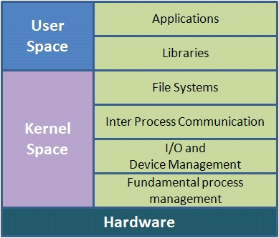

Different types of Computing:

Grid,

Cloud,

Utility,

Distributed and Cluster computing.

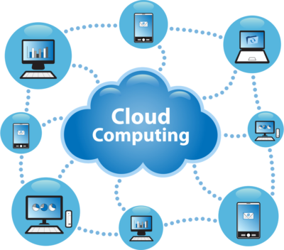

**Cloud Computing**

Cloud Computing has three main service areas. They are Software-as-a-Service (SaaS), Infrastructure-as-a-Service (IaaS) and Platform-as-a-Service (Paas). Cloud Computing uses network resources and operating systems release software to provide services. That makes up for the use of resources of the Volunteer Computing model.

credit; https://www.google.com/search?sxsrf=ACYBGNRCu25taCqUXb0Ifw0ZAdMn7IdZXQ%3A1578675404110&source=hp&ei=zKwYXr6oBMPJ-gSazqHgCA&q=computing+definition&oq=Computing+&gs_l=psy-ab.3.3.0j0i131j0l8.24712.29535..44174...3.0..0.110.982.11j2......0....1..gws-wiz.......35i39j35i39i70i249.fwtpYogyV5E

**Utility Computing:** The computer utility is a service provisioning model in which a service provider makes computing resources and infrastructure management available to the customer as needed, and charges them for specific usage rather than a flat rate.

credit: https://en.wikipedia.org/wiki/Utility_computing

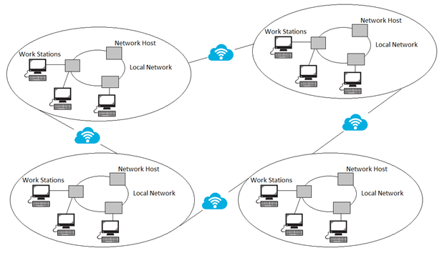

**Distributed computing:** is a model in which components of a software system are shared among multiple computers to improve efficiency and performance. According to the narrowest of definitions, distributed computing is limited to programs with components shared among computers within a limited geographic area.

credit: https://whatis.techtarget.com/definition/distributed-computing

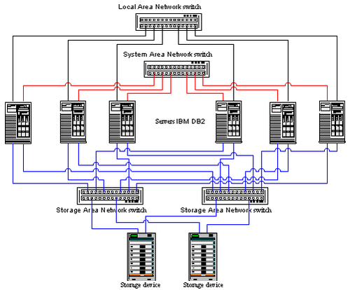

**Computer cluster**: A computer cluster is a set of loosely or tightly connected computers that work together so that, in many respects, they can be viewed as a single system. Unlike grid computers, computer clusters have each node set to perform the same task, controlled and scheduled by software.

credit: https://en.wikipedia.org/wiki/Computer_cluster

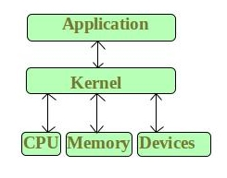

**Computer Resources**

Volunteer Computing makes use of the entire computers resources. Those resources are devices connected to a computer. Internal system parts are a resource. Things like files, file handles, network sockets in a folder, and memory areas. For example, new web pages are memory areas when saved to a folder. Using process IDs and socket files are some of the uses of resources in cloud computing.

**General resources**

Volunteer Computing makes use of general resources. CPU and Multiple CPU motherboards having Random-access memory and virtual memory. Utilizing hard disk drives and Cache and Cache space. Network bandwidth is a resource to be considered. Java scripts input/output operations using DOM or Document Object Model. Uses Objects that are also resources and memory spaces.

Credit: https://en.wikipedia.org/wiki/System_resource

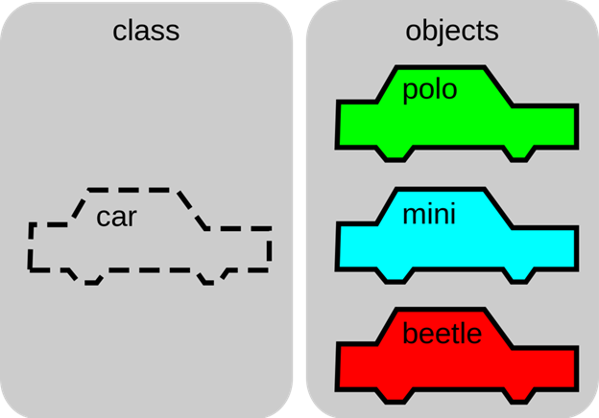

**Object-oriented programming**

Resources are encapsulated into objects. Objects are used to write programs. Java script programming using HTML protocol. Both have resources as objects. Some programming languages use file objects that have the (value of a file descriptor or file handle).

credit: https://en.wikipedia.org/wiki/Resource_management_(computing)

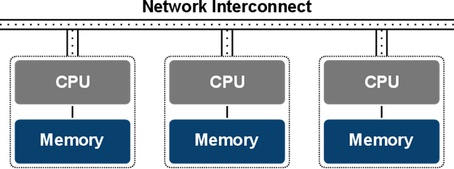

**Distributed Memory**

Volunteer Computing makes use of a resource called Distributed Memory. For example java script uses "web pages that are read as files, from the top to the bottom" by the computer CPU (Meridith, 2019). The data read in the file becomes an algorithm, that other computers can read and scale at any size. The advantage of shared distributed memory is that it, has a unified address space where all data can be found. In this case example, the file itself and it is compatible with all computers .

credit: https://en.wikipedia.org/wiki/Distributed_memory

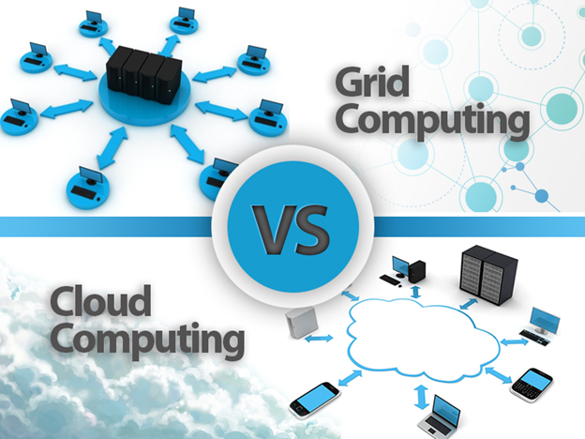

**Grid Computing**

Computer processors and electronic silicon integrated processors make up a custom designed computer motherboard. This new computer uses computer resources from certain computer communication domains or domains to connect to then form a main objective. The computers along with the custom computer on a network work together on a task. This makes up a supercomputer. Computer Engineering is within this field of work.

credit: https://www.techopedia.com/definition/87/grid-computing

**Why volunteer computing? (Tipnaree Tesprasit)**

It’s a free resource for those scientific research projects or organizations who have limited budget or cannot afford a large-scale computing. If those research projects or organizations are interesting and can draw attention from the public, they can earn huge support through volunteer computing. Generally, computers processing capacity is used around 10-15%. Therefore, there is a great deal of the power left. When gathering those available power from volunteer computers, it can enable scientific projects to run tasks without a need to purchase an awfully expensive supercomputer. More importantly, computations can be processed way faster when they are divided and distributed to one or more computers through the volunteer computing network. Furthermore, volunteer computing is another way to endorse public interests in science by donating their computer resources such as processing power, storage, and an internet connection.

**Ref**:

https://boinc.berkeley.edu/trac/wiki/VolunteerComputing

http://lhcathome.web.cern.ch/about/what-volunteer-computing

https://dzone.com/articles/the-power-of-a-volunteer-computer-network

**Outline:**

1. Intro (What is it?)
2. History
3. How does it work?
4. Uses and Applications
5. Volunteering
6. Results
   1. What does a “result” look like?
      1. Forms of results
         1. New scientific knowledge, such as that published in peer-reviewed journals
         2. Product breakthroughs, such as new disease treatments or new manufacturing materials
   2. Current and past projects
      1. Wikipedia currently lists 62 active projects
      2. BOINC hosts most scientific VC projects
      3. Cloud v. Volunteer <http://mescal.imag.fr/membres/derrick.kondo/pubs/kondo_hcw09.pdf>
   3. Past results
      1. GIMPS
         1. First volunteer computing project
         2. Lots of new prime numbers!
         3. Results not published beyond website?
      2. SETI@home
         1. 3rd large-scale use of volunteer computing
         2. In the Guinness Book of World Records for Largest Computation
      3. Folding@home
         1. 216 (and counting!) peer-reviewed papers from project
      4. Rosetta@home
         1. Won the Theory Feynman Prize in Nanotechnology for development of RosettaDesign in 2004
         2. Drug development
      5. Einstein@home
         1. Pulsar discovery
         2. "There are a lot of volunteer computing projects, and many have made scientific progress, but it has been largely incremental," said Anderson, project director of 11-year old SETI@home, the most popular volunteer computing project in history. "This is the first discovery of something new." (https://vcresearch.berkeley.edu/news/einsteinhomes-pulsar-discovery-proves-value-volunteer-computing)
   4. Future outcomes
      1. SETI@home
         1. Despite its popularity, no ETs have been found yet :(
      2. Biomedical
      3. Quake-Catcher Network
         1. Earthquake monitoring
         2. Volunteers can purchase a USB sensor to monitor seismographic activity

**History:**

* <https://en.wikipedia.org/wiki/Volunteer_computing#History>(Has a brief summary of the history of “Volunteer computing”)

**Volunteering**

* <http://faculty.poly.edu/~onov/Nov%20Anderson%20Arazy%20Volunteer%20Computing%20WWW.pdf> (paper about factors contributing to participation in a volunteer computing project)
* <https://cacm.acm.org/news/92931-what-motivates-volunteer-computing-contributors-it-depends/fulltext> (news article on above paper)
* <https://royalsocietypublishing.org/doi/full/10.1098/rsta.2010.0163> (paper on retaining volunteers in volunteer computing projects)

**Results:**

* <https://www.nature.com/articles/507431b> (2014 correspondence noting the lack of peer-reviewed publications from volunteer computing)
* <https://link.springer.com/chapter/10.1007/978-3-030-36592-9_59> (2019 paper about setting up and running a volunteer computing study)
* <https://web.archive.org/web/20051128165405/http://www.guinnessworldrecords.com/index.asp?id=53519> (SETI@HOME in Guinness Book of World Records for Largest Computation)
* <https://foresight.org/about/2004Feynman.php#2004Winners> (ROSETTA@HOME winning Feynman Prize)
* <https://www.livescience.com/8626-science-projects-run-home-computer.html> (article mentioning results of many VC projects)
* <https://www.discovermagazine.com/the-sciences/your-computer-can-volunteer-too> (links to papers with findings made possible by VC)

**Volunteer computing research positive results (AS):**

**GO Fight Against Malaria -**

“The GO Fight Against Malaria project team has been making good use of the calculations which were conducted by our volunteers and that concluded in summer 2013. Their findings have sparked progress against not only malaria, but tuberculosis as well. They have one paper published and two more about to be submitted. They continue their work to publish their findings, after which they will resume the analysis on and experimental assessment of the massive amount of data generated by World Community Grid volunteers.” (<https://www.worldcommunitygrid.org/about_us/viewNewsArticle.do?articleId=433>)

**Computing for Clean Water -**

“The Clean Water Project made an exciting discovery about the possible applications of carbon nanostructures to water purification, biomedical research, and energy research. Dr. Ming Ma, one of the scientists on the project, recently published a paper that summarizes the current status of work in this field.” (<https://www.worldcommunitygrid.org/about_us/viewNewsArticle.do?articleId=568>)

**Discovering Dengue Drugs – Together -**

“The Discovering Dengue Drugs research team has published a paper describing a new drug candidate that was discovered with the help of World Community Grid volunteers. This drug candidate has no known adverse risks, and seems to be an attractive candidate for preclinical studies. A new antiviral treatment would be hugely beneficial for roughly half of the world’s population that is at risk of contracting dengue or other related viruses such as hepatitis C, yellow fever and West Nile.” (<https://www.worldcommunitygrid.org/about_us/viewNewsArticle.do?articleId=398>)



**GENERAL INFO LINKS**:

* <http://lhcathome.web.cern.ch/about/what-volunteer-computing>
* <https://en.wikipedia.org/wiki/Volunteer_computing>
* [**https://boinc.berkeley.edu/trac/wiki/VolunteerComputing**](https://boinc.berkeley.edu/trac/wiki/VolunteerComputing)
* <http://faculty.poly.edu/~onov/Nov%20Anderson%20Arazy%20Volunteer%20Computing%20WWW.pdf>
* <https://en.wikipedia.org/wiki/List_of_distributed_computing_projects>
* <https://boinc.berkeley.edu/trac/wiki/VolunteerComputing>
* <https://science.sciencemag.org/content/329/5997/1305>
* <https://dzone.com/articles/the-power-of-a-volunteer-computer-network>
* <https://xrds.acm.org/article.cfm?aid=1734164>
* <https://medium.com/@elige/projects-based-on-volunteer-computing-6c0d3120a937>
* <https://www.geeksforgeeks.org/volunteer-and-grid-computing-hadoop/>
* <http://mescal.imag.fr/membres/derrick.kondo/pubs/kondo_hcw09.pdf> (about cloud computing versus volunteer computing)